1. DMI measurement attributes:

“Distress manifestations are visible signs of pavement structural condition. These distresses are indicators of problems due to material deficiencies, construction deficiencies, environmental and climatic conditions, traffic loading, or other causes, The degree of severity (How bad?) and density or extent of occurrence (How big?) of these distresses are good indicators of the problem. (G.J. Chong, 1989)

1. IRI is not subjective:

“The IRI is typically obtained using specialized equipment which indicates the smoothness of the roadway segment based on established computer algorithms, …” “More importantly, IRI is not a subjective measure, compared to PCI. The statistical significance of some of these relationships or models developed also suggest that one variable can be predicted or estimated from the other, depending on data availability and quality.” From the literature review, a variety of statistically significant models or relationships between the IRI and PCI (and other pavement indices) were identified for various jurisdictions. The studies also reveal the notion that it is acceptable to use the IRI as a predictor variable of PCI. The IRI, which is a profile-based statistic, is shown to be an ideal predictor (or independent variable) since it has the advantage of being repeatable, reproducible, and stable with time. The vast variations of models developed between IRI and PCI is a strong indication that models can only be developed exclusively for each jurisdiction. The statistically significant relationships or models developed for these variables also suggest that one variable can be predicted or estimated from the other.” (Stephen A. Arhin, 2015)

1. Causes of Pavement Deterioration

“IV. CAUSES OF PAVEMENT DETERIORATION

(i)Sudden increase in traffic loading especially on new roads where the design is based on lesser traffic is a

major cause of cracking. After construction of good road, traffic of other roads also shifts to that road. This

accelerates the fatigue failure (Alligator Cracking).

(ii)Temperature variation ranging from 50º C to below zero conditions in the plain areas of North and Central

India leads to bleeding and cracking.

(iii) Provision of poor shoulders leads to edge failures.

(iv) Provision of poor clayey subgrade results in corrugation at the surface and increase in unevenness.

(v) Poor drainage conditions especially during rainy seasons, force the water to enter the pavement from the sides as well as from the top surface. In case of open graded bituminous layer, this phenomenon becomes more dangerous and the top layer gets detached from the lower layers.

(vi) If the temperature of bitumen/bituminous mixes is not maintained properly, then it also leads to pavement failure. Over heating of bitumen reduces the binding property of bitumen. If the temperature of bituminous mix has been lowered down then the compaction will not be proper leading to longitudinal corrugations.” (Sharad.S.Adlinge, 2013)

1. IRI measurement range

“

Good: IRI less than 95 inches/mile

Fair: IRI between 95 and 170 inches/mile

Poor: IRI greater than 170 inches/mile

“ (MDOT, 2017)

1. PCI measurement:

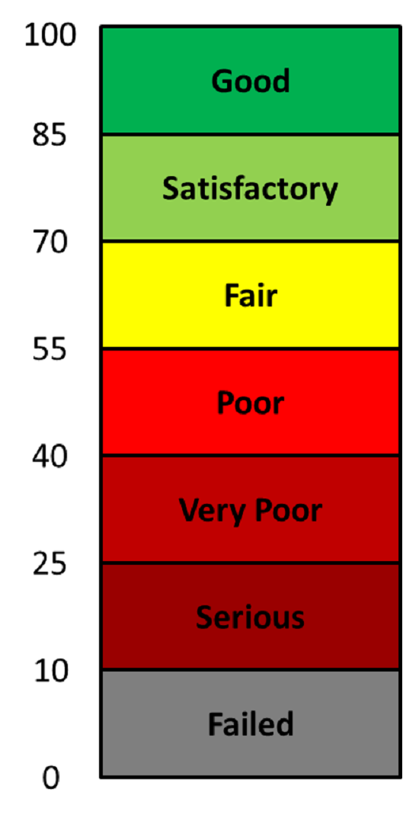 (FAA, n.d.) (PCI, FAA -Federal Aviation Administration)

1. DMI measurement range:

“DMI is the subjective Distress Manifestation Index ranging from 0 (worst condition) to 10 (excellent condition)” (Veen, 2020)

# References

FAA. (n.d.). *FAA PaveAir Help.* Retrieved from Pavement Condition Index (PCI): https://faapaveair.faa.gov/Help/PavementConditionIndexPCI.html

G.J. Chong, W. P. (1989, August). Manual for Condition Rating of Flexible Pavements - Distress Manifestations. Ontario, Canada: Ministry of Transportation of Ontario.

MDOT. (2017, November). *International Roughness Index (IRI).* Retrieved from michigan.gov: https://www.michigan.gov/documents/mdot/International_Roughness_Index_605990_7.pdf

Sharad.S.Adlinge, P. (2013). Pavement Deterioration and its Causes. *IOSR Journal of Mechanical & Civil Engineering (IOSR-JMCE)*, 9-15.

Stephen A. Arhin, L. N. (2015). Predicting Pavement Condition Index Using International Roughness Index in a Dense Urban Area. *Journal of Civil Engineering Research*, 10-17.

Veen, D. V. (2020, November). *10 YEAR PAVING STRATEGY AND PAVEMENT MANAGEMENT PLAN FNAL REPORT (REVISED).* Retrieved from king.ca: https://www.king.ca/sites/default/files/docs/local-government/strategic-initiatives-master-plans/COW%20_7%20-%20PW-CAP-2020-25%20-%20Appendix%20A%20-%2010%20Year%20Paving%20Strategy.pdf